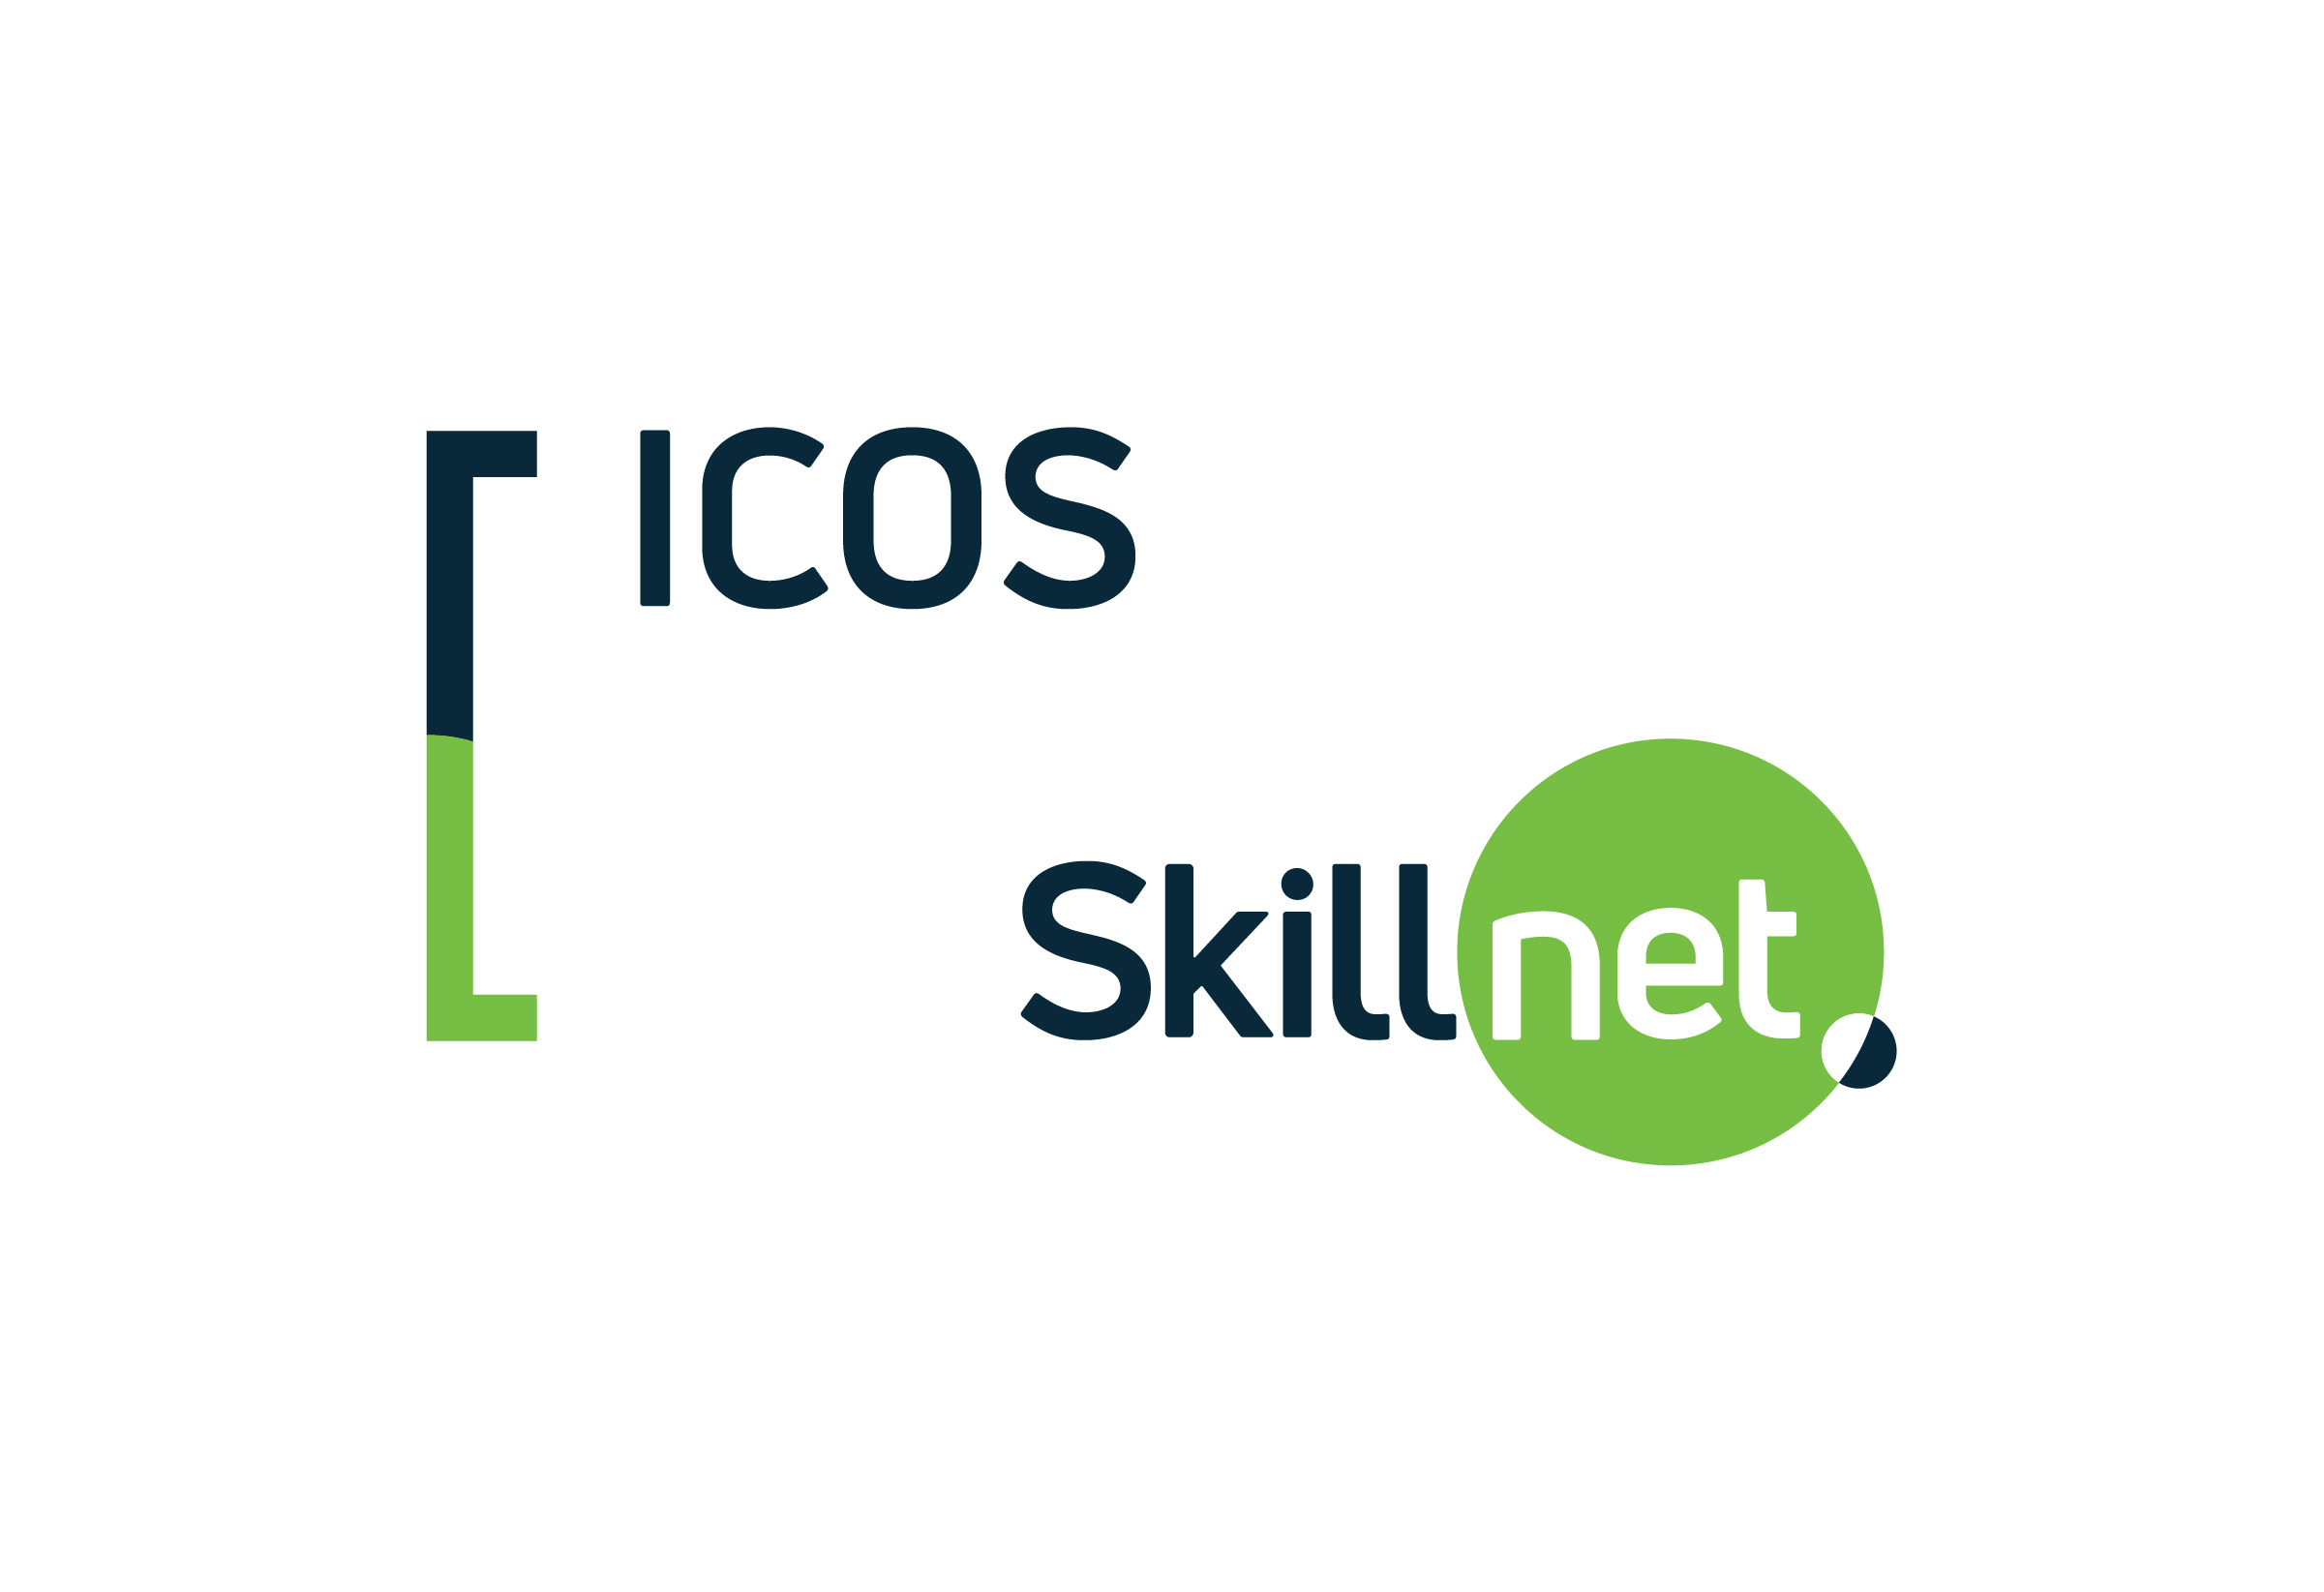

ICOS SKILLNET- SIGN IN SHEET

Course Name:

Location:

Date:

Welcome to your ICOS Skillnet training programme. This sign-in-sheet is used to verify trainee attendance. Your data will be processed in line with all applicable Data Protection Legislation and the Skillnet Ireland Privacy Statement which you can access on the Skillnet Ireland website at http://www.skillnetireland.ie/data-protection/Skillnet-Ireland-Trainee-Privacy-Statement

NAME (Please Print) | SIGNATURE | CO-OP

